Sample queries to practice

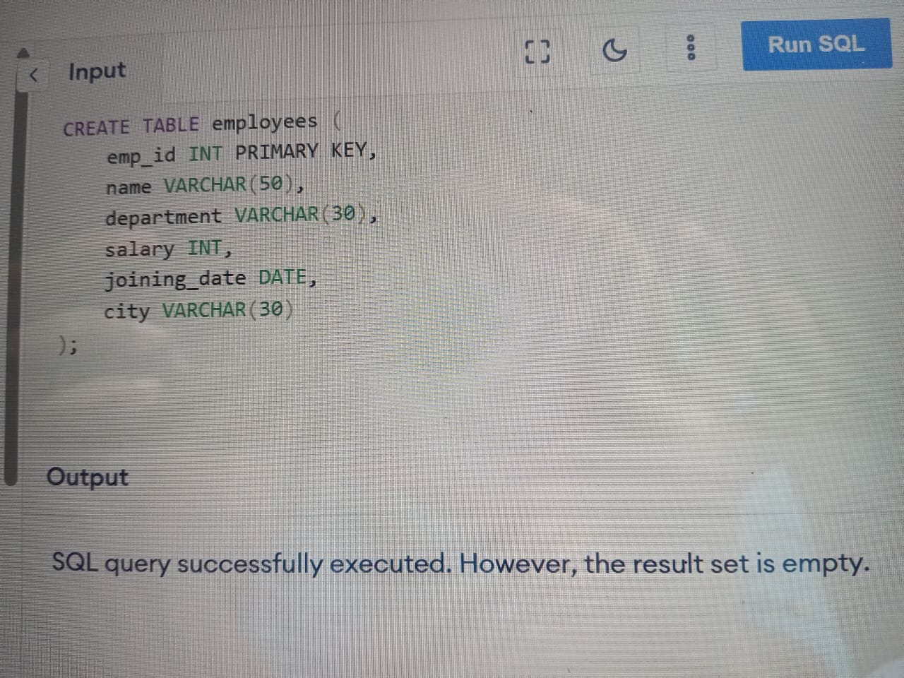

INSERT INTO employees (emp_id, name, department, salary, joining_date, city) VALUES

(1, 'Alice Smith', 'HR', 45000, '2020-02-15', 'New York'),

(2, 'Bob Johnson', 'IT', 60000, '2019-08-23', 'Chicago'),

(3, 'Carol White', 'IT', 75000, '2021-01-10', 'New York'),

(4, 'David Brown', 'Finance', 50000, '2020-06-01', 'San Diego'),

(5, 'Eva Adams', 'HR', 47000, '2018-04-12', 'Chicago'),

(6, 'Frank Lee', 'Finance', 65000, '2021-11-05', 'New York'),

(7, 'Grace Kim', 'IT', 80000, '2017-09-18', 'San Diego'),

(8, 'Henry Clark', 'Marketing', 55000, '2019-12-29', 'Chicago'),

(9, 'Irene Scott', 'Marketing', 53000, '2021-03-22', 'New York'),

(10, 'Jack Davis', 'IT', 72000, '2020-08-14', 'Chicago');

1ans)

SELECT *

FROM employees

WHERE department = 'IT';

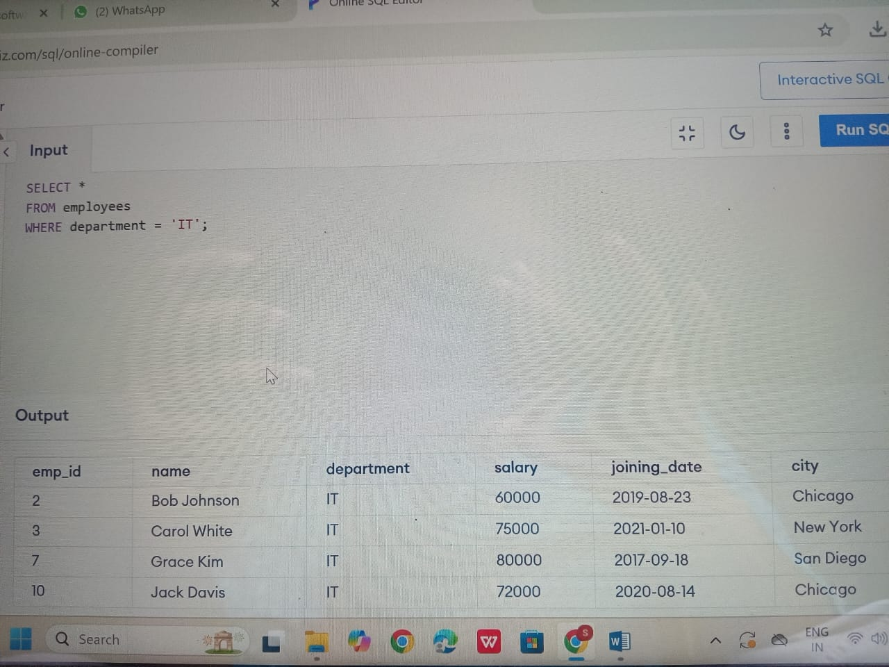

2ans)

SELECT *

FROM employees

WHERE salary > 60000;

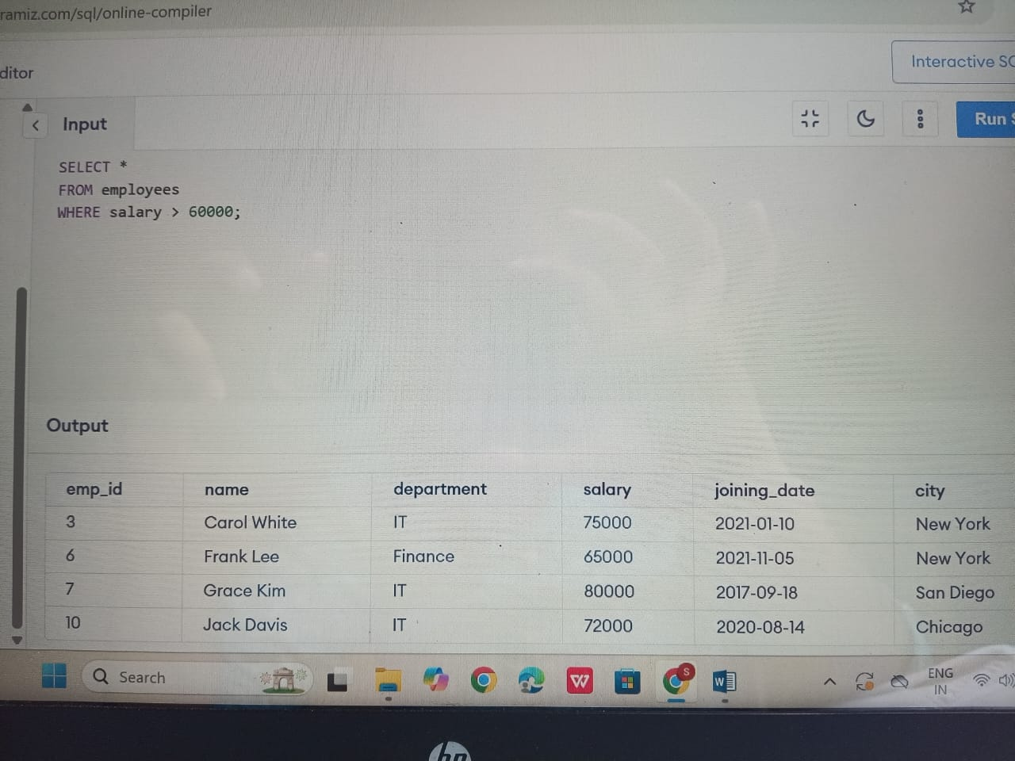

3ans)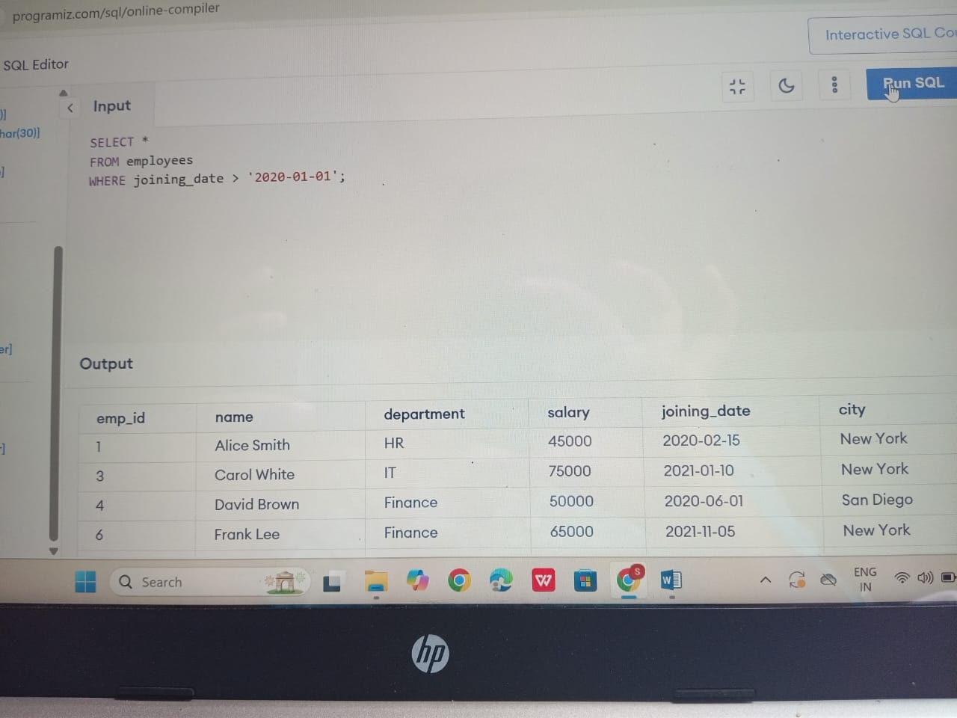

4ans)

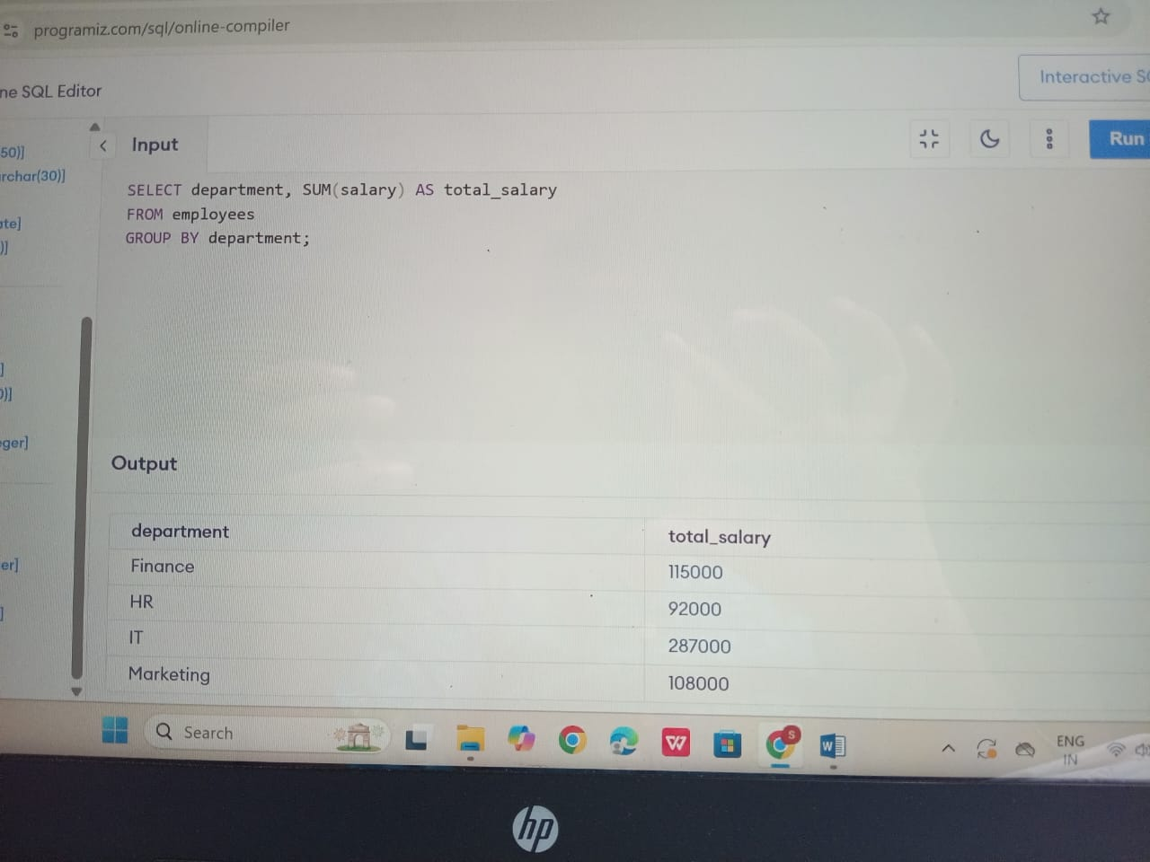

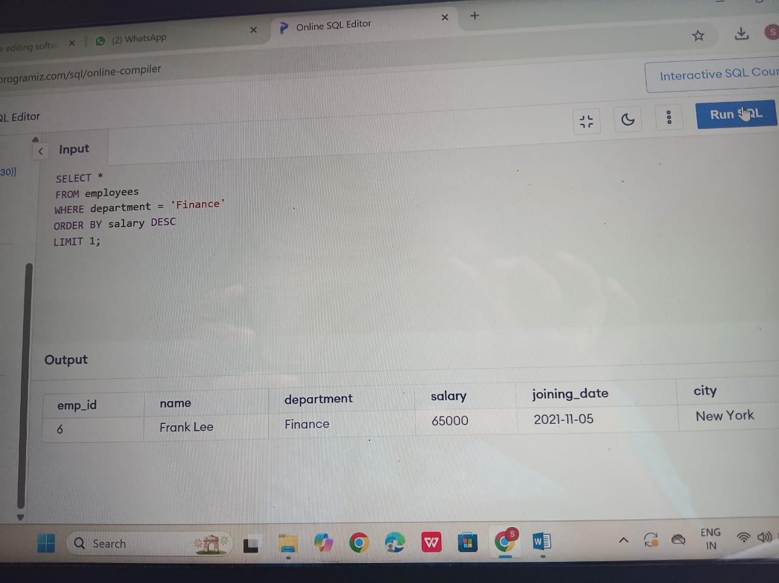

6ns)

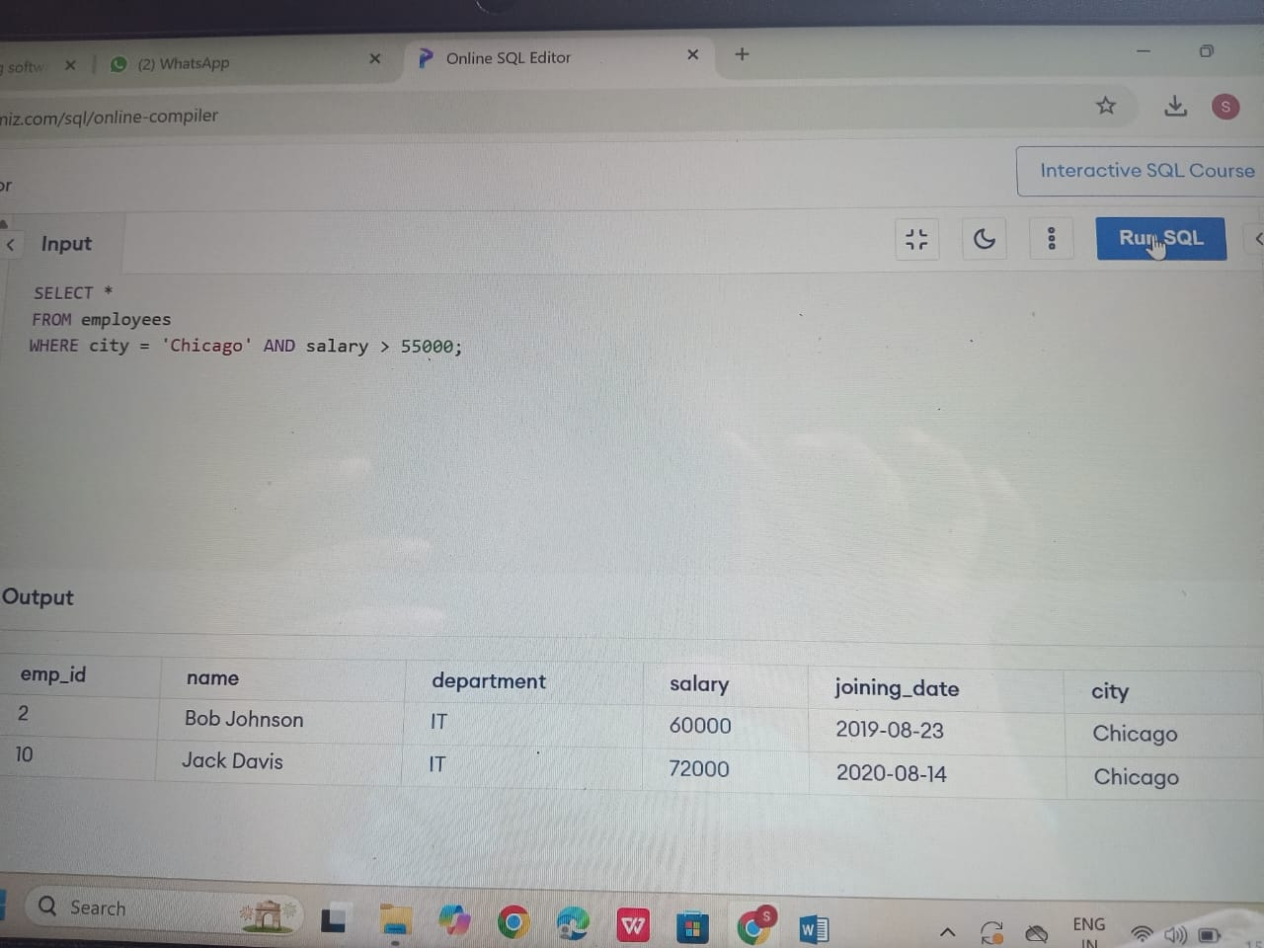

7ns)

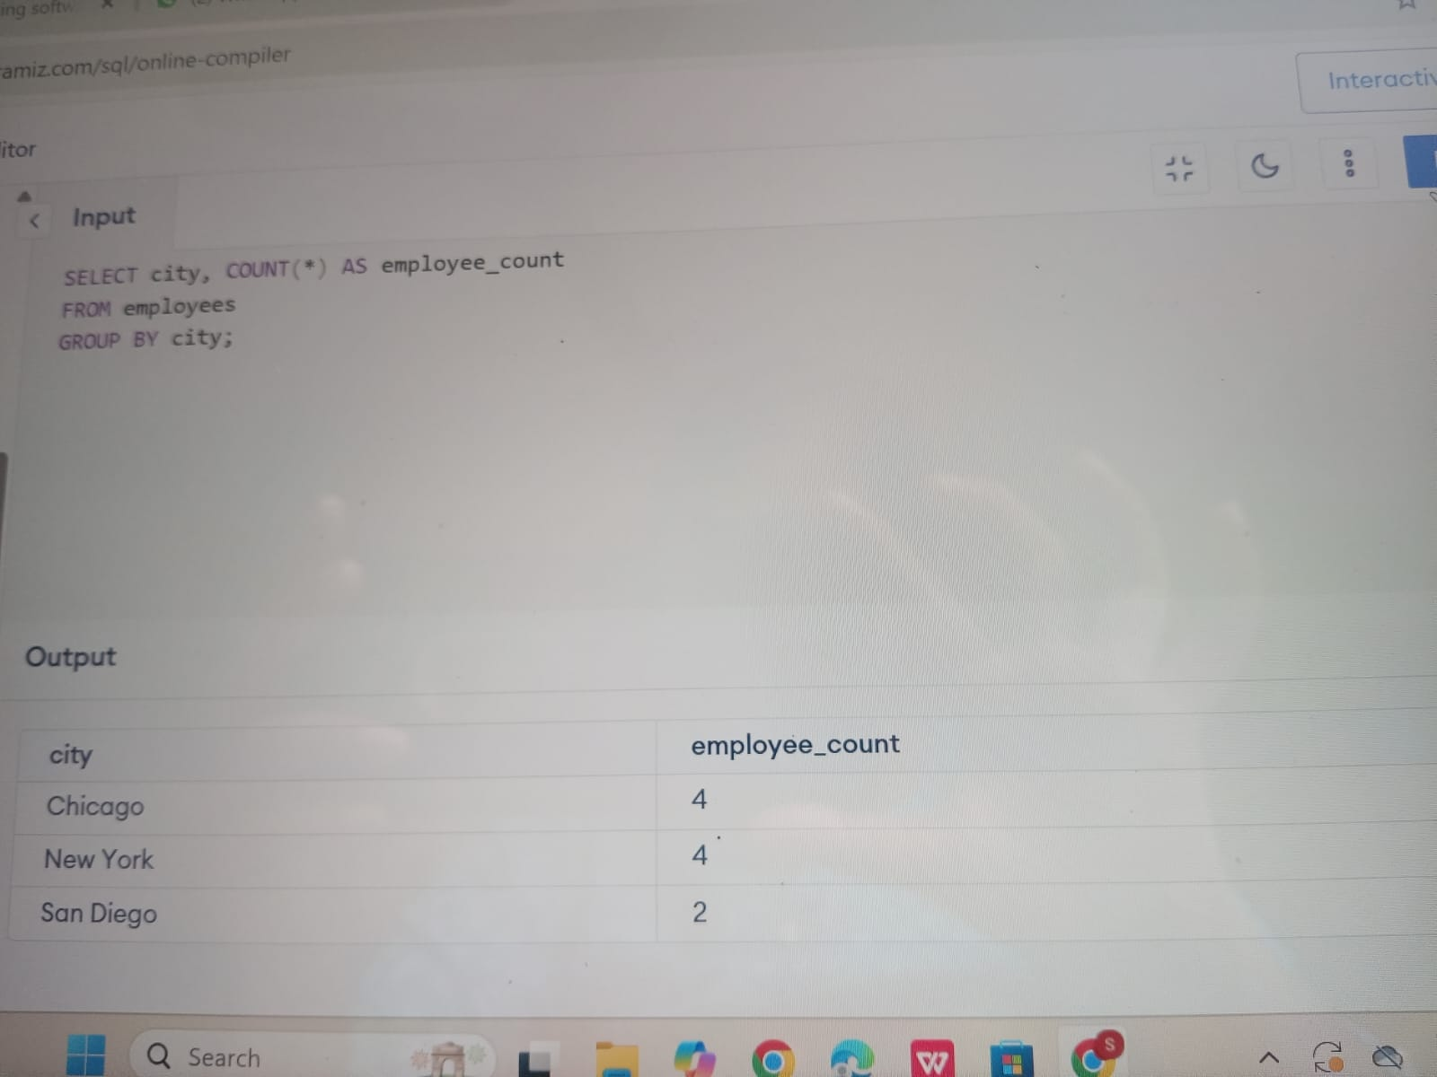

8ans)

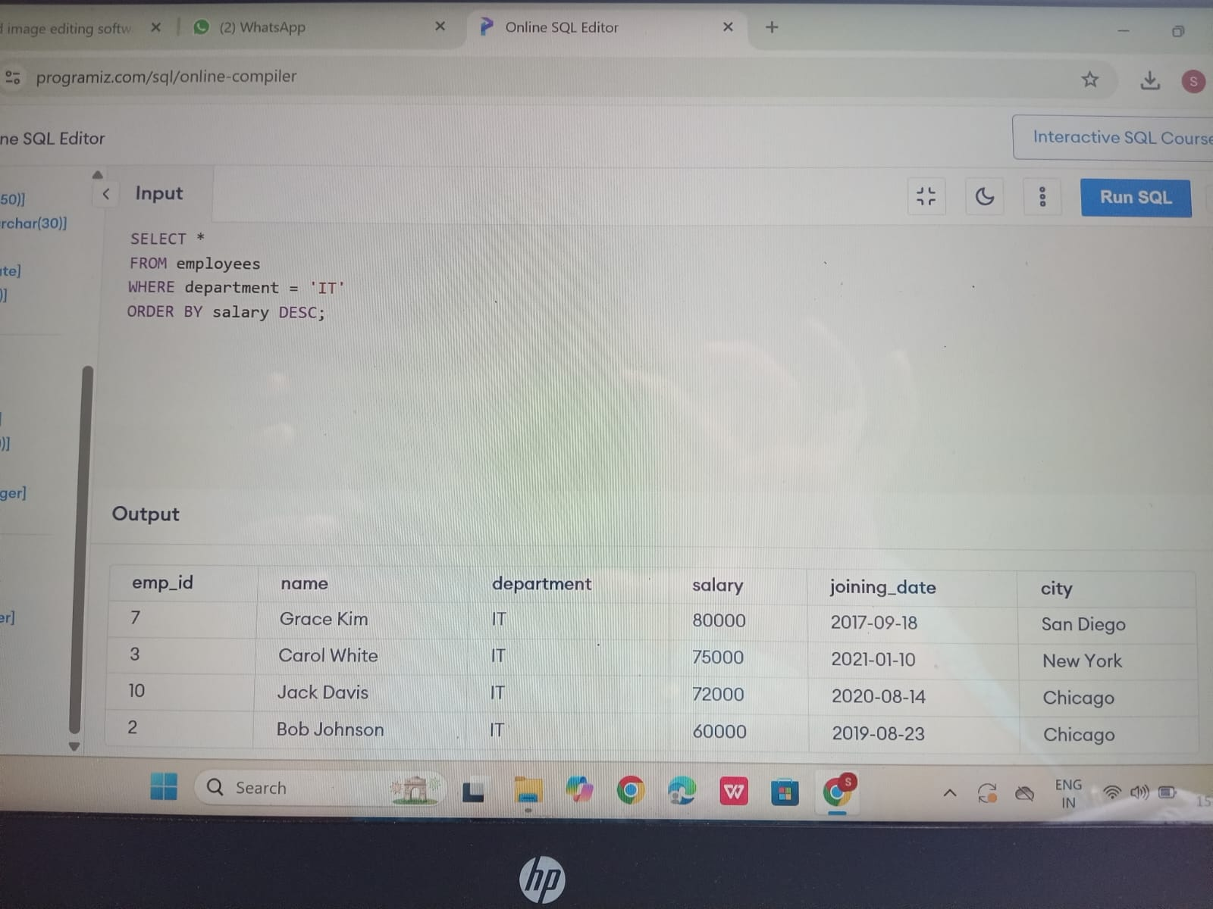

9ans)

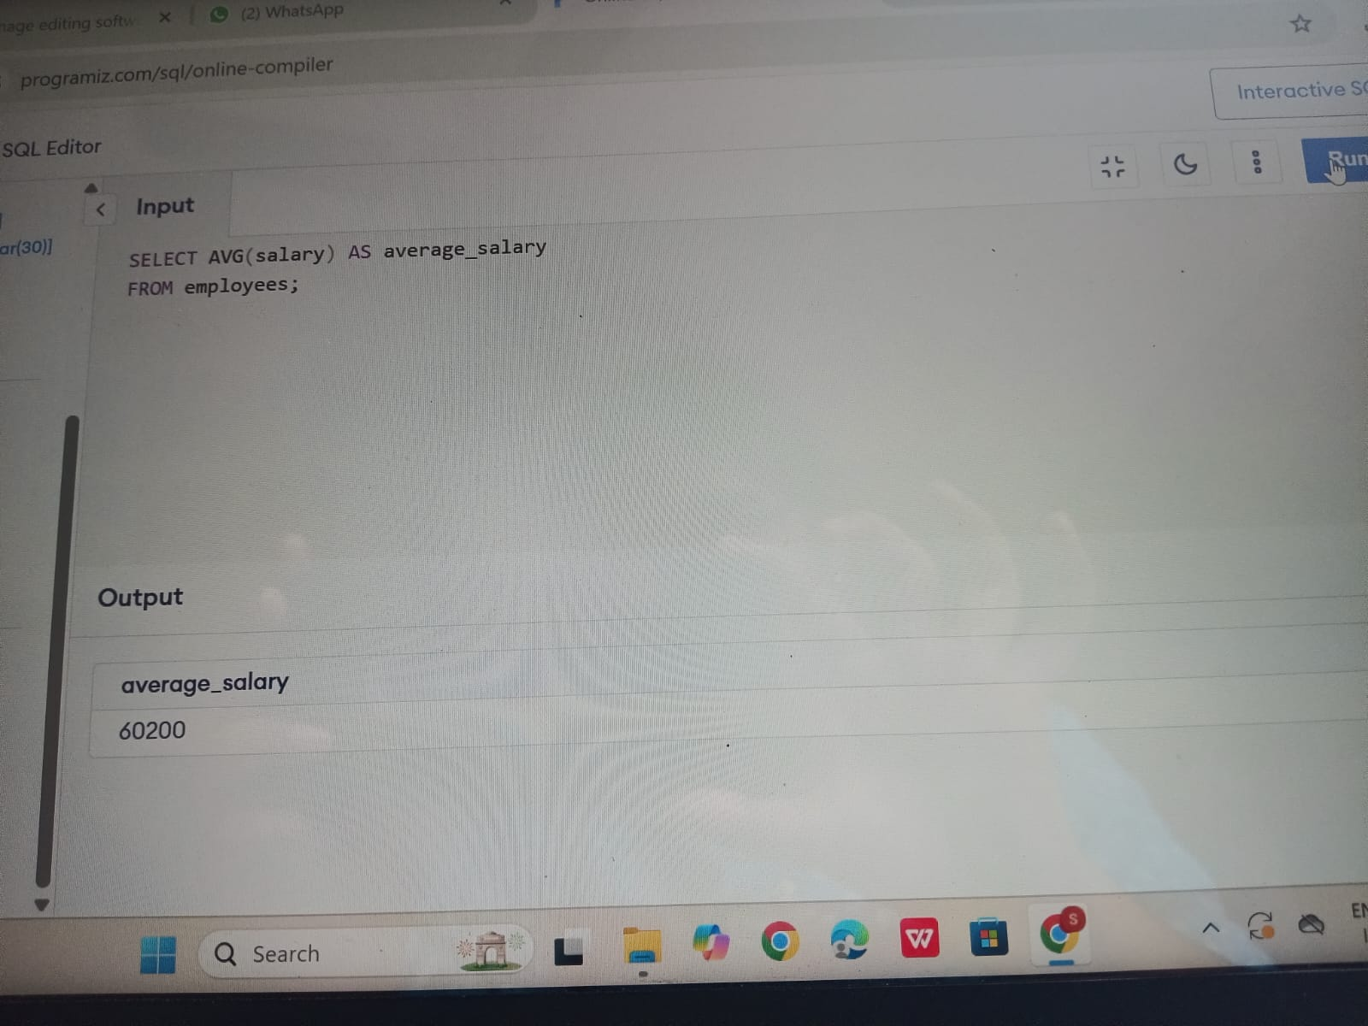

10ans)

